
Harlington Parish Council

Parish Council Office, Rear of Parish Hall, Church Road, Harlington, Bedfordshire LU5 6LE
The Clerk to the Council Telephone: 01525 875933 Email: clerk@harlington-pc.gov.uk
Notice is hereby given that Members of the Parish Council are summonsed to attend an Ordinary Meeting of the Full Council to be held on Tuesday 22nd July 2025 at 7.30 pm in the West Room of the Parish Hall for the purpose of transacting business as detailed in the following AGENDA. Press and Public are welcome to attend, but may be required to leave the meeting if a special or confidential matter is to be discussed.
Alison Doyle Clerk to the Council. Date: 17th July 2025

AGENDA

25FC137 To receive apologies for absence
Local Government Act 1972 s85 (1)

25FC138 To receive Declarations of Interest and consider requests for dispensations concerning items on the Agenda
Localism Act 2011 C7 s31 and Localism Act 2011 C7 s33

25FC139 To approve the accuracy of the Draft Minutes of the last meeting of the Full Council held on
8th July 2025
Local Government Act 1972 Sch12, part V1 41 (1)
25FC140 To receive Report of Central Bedfordshire Councillors (residents can obtain copies of submitted written reports by emailing the Clerk)
25FC141 Public Question Time
The meeting will be adjourned for 10 min for members of the public to ask question or make
comments on items of business on the agenda

PLANNING The following planning matters have been received from Central Bedfordshire, to agree
comments to be submitted back to Central Bedfordshire.
Town and Country Planning Act 1990 Sch1 p8
-applications can be viewed on the CBC website via:
http://plantech.centralbedfordshire.gov.uk/PLANTECH/DCWebPages/AcolNetCGI.gov

25FC142 Planning Applications for consultation
Planning number:  CB/25/02164/FULL | Consultation Expires:  07/08/2025 | Location:  Land adj to Southview, 5, Toddington Rd, Harlington, Dunstable, LU5 6LB | Proposal:  New vehicular crossover 5M
RESOLVED
Planning number:  CB/25/02017/FULL | Consultation Expires:  01/08/2025 | Location:  Land south of Greenfield Road and Clayhill Farm, Greenfield Road, Westoning | Proposal:  Construction of a temporary Solar Farm, to include the installation of Solar Panels with transformers, a substation, a DNO control room, a customer substation, GRP comms cabin, security fencing, landscaping and other associated infrastructure and works.
RESOLVED

FINANCIAL MATTERS
25FC143 To receive the Account balances report as at 17/7/25
HPC Ear Marked Funds account (Ring-fenced) £150,488.58
HPC General Reserve Account £ 53,134.22
HPC Current Account £ 48,400.05

25FC144 To Agree and authorise items for Payment

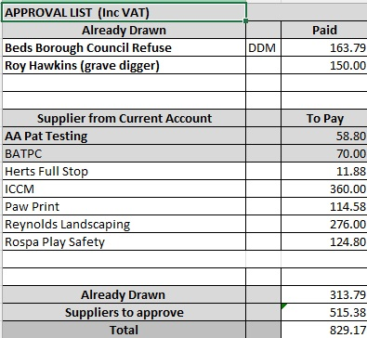

GENERAL MATTERS
25FC145 To receive the Clerk’s/Chairman’s Report (project updates)
25FC146 To agree to return the key used at the low level stop cock in allotments to the rightful owner.
25FC147 To receive and agree a list of names of veterans from the wall memorial for proposed street names for the Castlefield Park development

Work quotations to consider

25FC148 To receive and agree the additional cost from CDS for supplying warning labels and ties to both
Cemeteries.

25FC149 To receive and consider tree works to be carried out on trees in Pilgrims Close and New Grounds that could potentially cause and accident

25FC150 To receive and agree Reynolds Landscaping to replace a wooden post missing from the Village Hall Carpark

25FC151 To receive and agree AA Pat Testing recommendations of a new co2 extinguisher

To resolve to invoke Standing Order 19f:
“That in view of the confidential nature of the business about to be transacted, it is advisable in the public interest that the press and public be temporarily excluded and they are instructed to withdraw”
25FC152 Staffing matters – Confidential

The next meeting of the Full Parish Council will take place on 9th Sept 2025

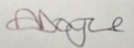
Alison Doyle Proper Officer (Clerk & RFO) Clerk 17th July 2025

