
Harlington Parish Council

Parish Council Office, Rear of Parish Hall, Church Road, Harlington, Bedfordshire LU5 6LE
The Clerk to the Council Telephone: 01525 875933 Email: clerk@harlington-pc.gov.uk
Notice is hereby given that Members of the Parish Council are summonsed to attend an Ordinary Meeting of the Full Council to be held on Tuesday 9th December at 7.30 pm in the West Room of the Parish Hall for the purpose of transacting business as detailed in the following AGENDA. Press and Public are welcome to attend, but may be required to leave the meeting if a special or confidential matter is to be discussed.
Alison Doyle Clerk to the Council. Date: 4th December 2025

AGENDA

25FC223 To receive apologies for absence
Local Government Act 1972 s85 (1)

25FC224 To consider co-option applications
25FC225 To receive Declarations of Interest and consider requests for dispensations concerning items on the Agenda
Localism Act 2011 C7 s31 and Localism Act 2011 C7 s33

25FC226 To approve the accuracy of the Draft Minutes of the last meeting of the Full Council held on
11th November 2025
Local Government Act 1972 Sch12, part V1 41 (1)
25FC227 To receive Report of Central Bedfordshire Councillors (residents can obtain copies of submitted written reports by emailing the Clerk)
25FC228 Public Question Time
The meeting will be adjourned for 10 min for members of the public to ask question or make
comments on items of business on the agenda

Planning Matters

25FC229 To discuss and formulate a response to the following planning application(s):
- Planning Application No. CB/25/03189/OUT
Proposal of 650 dwellings, 50 assisted living units for the elderly, upto 20 retirement bungalows and retail space.
Land South of Toddington Road and South of Westoning Road, Harlington
The above application(s) can be viewed at http://www.centralbedfordshire.gov.uk/planning-register by entering the application reference CB/25/03189/OUT

PLANNING The following planning matters have been received from Central Bedfordshire, to agree
comments to be submitted back to Central Bedfordshire.
Town and Country Planning Act 1990 Sch1 p8
-applications can be viewed on the CBC website via:
http://plantech.centralbedfordshire.gov.uk/PLANTECH/DCWebPages/AcolNetCGI.gov

25FC230 Planning Applications for consultation
Planning number: CB/25/03189/OUT | Consultation Expires:12/12/25 | Location: | Proposal: Hybrid planning application comprising: (1) Outline application for a residential development (up to 650 dwellings), and up to 50 assisted living units for the elderly (Use Class C2), up to 20 retirement bungalows (use Class C3), local centre including retail space of up to 1,050m², land for a medical centre of up to 420m², employment use of up to 2,000m², sports pavilion (for changing rooms and community use), mobility hub, pumping stations, associated works including infrastructure, vehicular, pedestrian and cycle access, blue and green infrastructure and landscaping/drainage attenuation. Demolition of the existing farmhouse and buildings at New Manor Farm off Toddington Road. All matters reserved except for access; and (2) Full application for the realignment of Toddington Road including a new junction with A5120
  Land south of Toddington Road and land south of Westoning Road, Harlington
RESOLVED
Planning number:  CB/TCA/25/00523 | Consultation Expires:10/12/25 | Location: Old Manor Farm, Station Road, Harlington, Dunstable, LU5 6LD | Proposal: Works to trees within a Conservation Area: Up to 2.5m reduction to  Beech Tree, as it is currently in the roof of his out-building which is  causing concerns. Re-Pollard 2 Acacia Trees to previous points, due to  decay at the unions taking some weight of the tree would reduce the  strain
RESOLVED
Planning number: CB/TRE/25/00498 | Consultation Expires:12/12/25 | Location: 4 Manor Close, Harlington, Dunstable, LU5 6PG | Proposal: Works to a trees protected by a Tree Preservation Order:  MB/35/2004/G1 (T5 & T6) Oak trees, remove to near ground level and  treat stump to inhibit re growth. Clay shrinkage subsidence damage at  the property
RESOLVED
Planning number:CB/25/03599 | Consultation Expires:19/12/25 | Location: Land to the West of the Mainline Railway Line and North of Toddington Road, Harlington | Proposal:
  Discharge of Condition 24 against planning permission CB/21/05416/OUT (Outline application: for up to 400 dwellings including land for a Primary School, open space and associated infrastructure. New main access, plus minor access to serve units to south east of site, off Toddington Road all matters reserved except access)
RESOLVED

FINANCIAL MATTERS
25FC231 To receive the Budget vs Actual Report

25FC232 To approve the precept budget and agree its submission to CBC

25FC233 To receive the Account balances report as at 04/12/25
HPC Ear Marked Funds account (Ring-fenced) £170,860.00
HPC General Reserve Account £ 53,134.22
HPC Current Account £ 67,323.95

25FC234 To Agree and authorise items for Payment

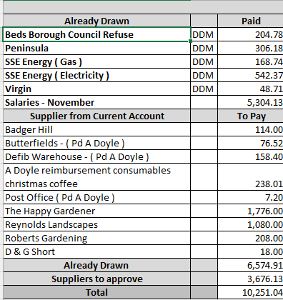

GENERAL MATTERS
25FC235 To receive the Clerk’s/Chairman’s Report (project updates)
25FC236 To receive the Correspondence Report (if any relevant)
25FC237 To consider suggestions for CBC regarding S106 monies allocation
25FC238 Remembrance Day – To consider purchasing an additional 12 lamppost poppies @ a cost of £36.00
25FC239 To consider organising Harlington Christmas Event / Light Switch on (2026)
25FC240 To receive last months interim Crime Statistics along with the Street Watch report

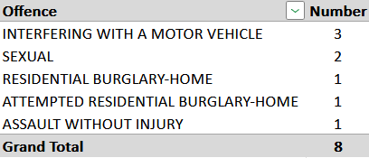

To resolve to invoke Standing Order 19f:
“That in view of the confidential nature of the business about to be transacted, it is advisable in the public interest that the press and public be temporarily excluded and they are instructed to withdraw”
25FC241 To receive Finance and General Purposes report and ratify decisions taken
25FGP66 Clerk to Study temporarily at home was confirmed
25FGP67 The Appointment of the new Office Assistant was confirmed.

The next meeting of the Full Parish Council will take place on 13th January 2026
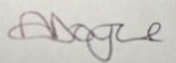
Alison Doyle Proper Officer (Clerk & RFO) Clerk 4th December 2025

