
Harlington Parish Council

Parish Council Office, Rear of Parish Hall, Church Road, Harlington, Bedfordshire LU5 6LE
The Clerk to the Council Telephone: 01525 875933 Email: clerk@harlington-pc.gov.uk

Notice is hereby given that Members of the Finance & General Purposes committee are summonsed to attend a Meeting of the Finance & General Purposes Committee to be held on Tuesday 3rd March 2026 at 7.30 pm in the West Room of the Parish Hall for the purpose of transacting business as detailed in the following AGENDA. Press and Public are welcome to attend, but may be required to leave the meeting if a special or confidential matter is to be discussed.
Alison Doyle Clerk to the Council. Date: 26th February 2026

AGENDA

26FGP01 To receive Apologies for Absence

26FGP02 To receive Declarations of Interest and consider requests for dispensations concerning items on the Agenda

26FGP03 To approve Minutes of the Meeting held on 2nd December 2025

26FGP04 Public Question Time
The meeting will be adjourned for 10 min for members of the public to ask question
or make comments on items of business on the agenda

26FGP05 To receive the Clerk’s/Chairman’s Report (project updates)

Finance
26FGP06 To receive the Income & Expenditure Year to date report:
26FGP07 To review and verify the Bank Reconciliations
26FGP08 To receive the Internal Controls Checklist for 03.03.2026
26FGP09 To consider new projects and associated funding to be undertaken with funds to be ear-marked
26FGP10 To consider the movement of funds from the current account to the EMF accounts.
26FGP11 To consider the list of regular payments for 2026/2027

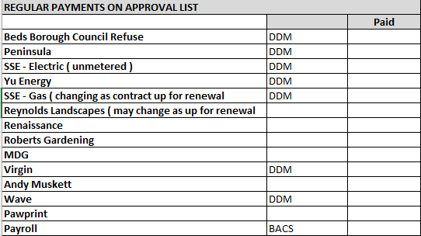

26FGP12 To review and consider the Statement of Internal Control for the year ending 31.03.27
26FGP13 To authorise the purchase of a Cordless Battery strimmer that was previously agreed (25FC172 to seek a ward councillor grant to provide match funding for the purchase of a battery powered strimmer/brushcutter). Due to the timescale of the grant F&GP is required to authorise payment and Full Council to ratify.

26FGP14 To receive and agree on Virgin Media quotations

26FGP15 To receive and agree quotes for Gas contract

26FGP16 To receive and agree tenders for Grass cutting for 2026-2028

Policy and Procedure Reviews

26FGP17 To review and update Model Standing orders (NALC)
26FGP18 To review and update the Grievance Policy (NALC)
26FGP19 To review the Financial Regulations ( NALC )
26FGP20 To review the Financial Regulations Appendix – RFO Responsibilities
26FGP21 To review Committee Terms of Reference
26FGP22 To review the Health & Safety Policy – To be reviewed 2nd June 2026

To review risk assessments

26FGP23 A Report on Risk Assessments – To be reviewed 2nd June 2026
Appendix 1 CONTROL SHEET – To be reviewed 2nd June 2026
Appendix 2 Allotment - Risk Assessments – To be reviewed 2nd June 2026
Appendix 3 Litter Picking- Risk Assessments – To be reviewed 2nd June 2026
Appendix 4 Fire Risk - Risk Assessment – To be reviewed 2nd June 2026
Appendix 5 IT- Risk Assessment for Fire Safety – To be reviewed 2nd June 26
Appendix 6 Outdoor-Play-Equipment- Risk Assessment – To be reviewed 2nd June 2026
Appendix 7 Stability Testing- Risk Assessments – To be reviewed 2nd June 2026
Appendix 8 Snow & Ice Clearance - Risk Assessments – To be reviewed 2nd June 2026
Appendix 9 Business Risk Management- Risk Assessment – To be reviewed 2nd June 2026

To resolve to invoke Standing Order 19f:
“That in view of the confidential nature of the business about to be transacted, it is advisable in the public interest that the press and public be temporarily excluded and they are instructed to withdraw”

Staffing matters
26FGP24 To review and consider IOSH Managing Safely course
26FGP25 Confidential Matters

The next meeting of the F&GP Committee will take place on 2nd June 2026
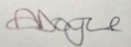
Ms Alison Doyle
Harlington Parish Clerk & RFO Date 26th February 2026

